C:\Documents and Settings\sschmidt\Local Settings\Temporary Internet Files\Content.IE5\0JAXMH8Z\MC900331193[1].wmf

1. Faith
2. Family
3. Friends



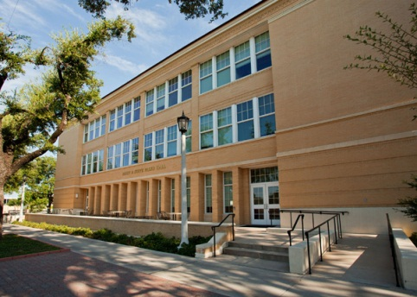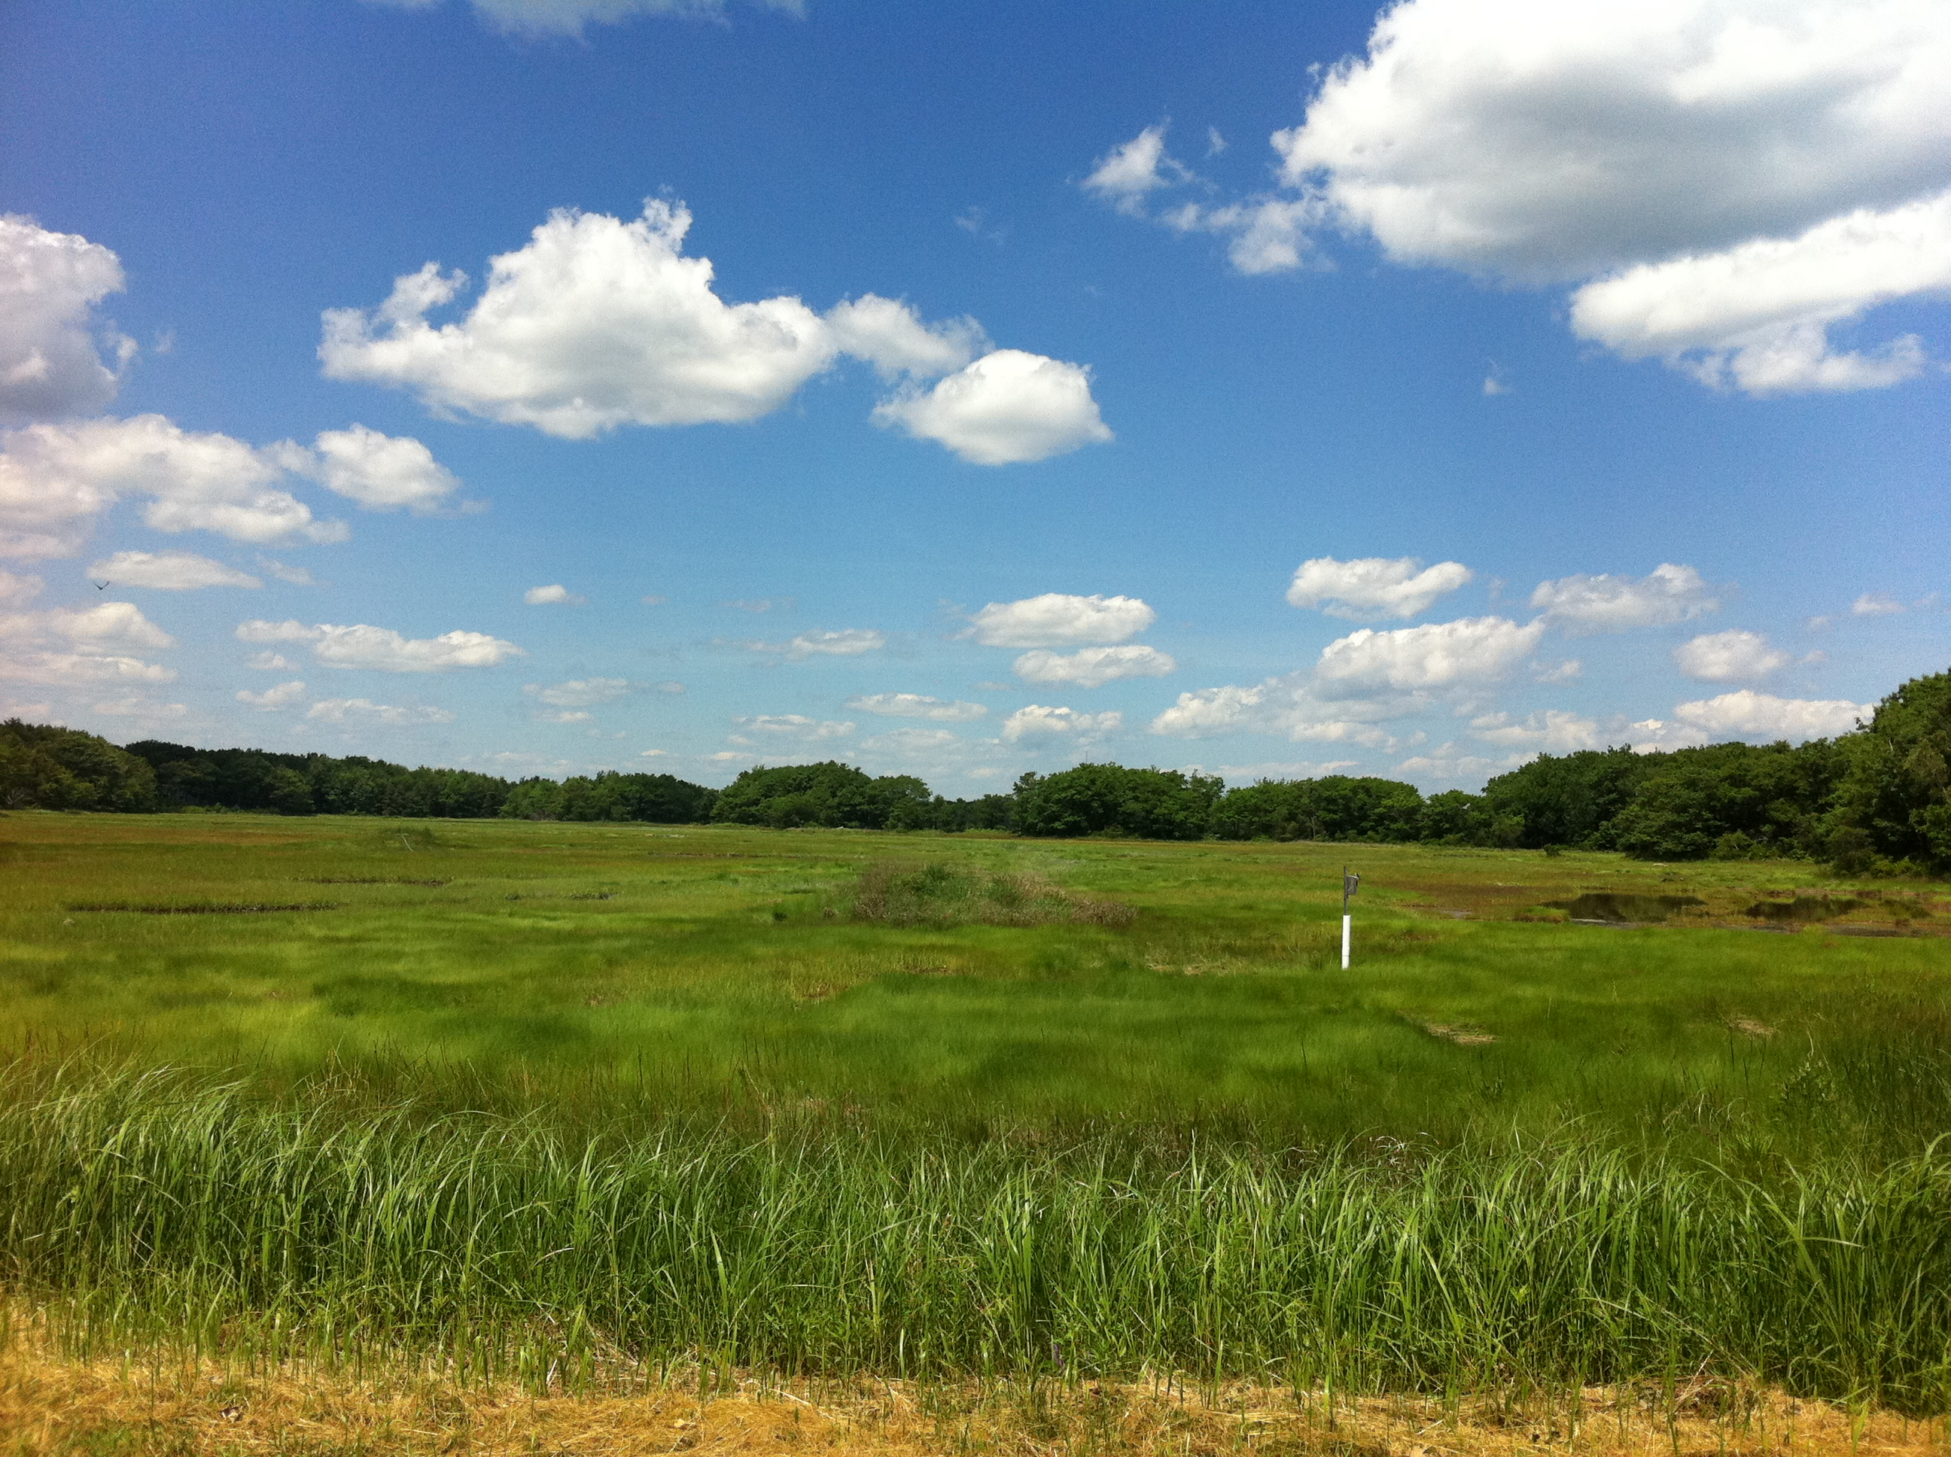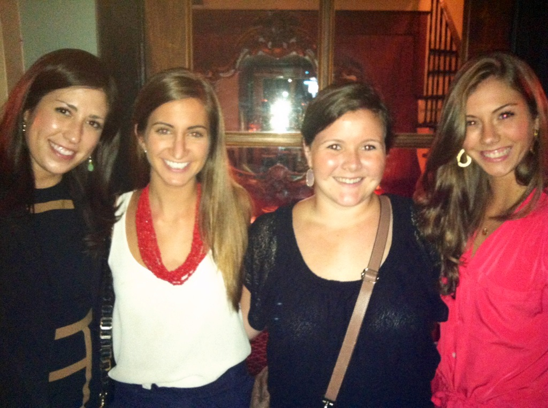



*I* ***am the first-born child of David and Amy Schmidt. My first home was in Miami, Florida and at the age of 10, we moved to Fort Worth, Texas.***

***I graduated from TCU in December 2010 with a Bachelor of Science degree in Early Childhood Education.***

***Kennebunkport, Maine is a home away from home for the 4 generations of my family who have enjoyed making many blessed memories on this coast.***